

***Version 2.0***

***Author: The Avengroid Team***

For e-Commerce System

Module: backend

**SCRUM PROCESS**

**Revision History**

|  |  |  |  |  |
| --- | --- | --- | --- | --- |
| NO. | DATE | VERSION | DESCRIPTION | AUTHOR |
| 1 | 10/11/2012 | 1 | Create document | Thanh Truong |
| 2 | 16/03/2013 | 1.2 | Update document | Phuong Nguyen |
| 3 | 18/04/2013 | 2.0 | Update document   * Introduction * Terminology * Roles and personnel in project | Phuong Nguyen |
|  |  |  |  |  |
|  |  |  |  |  |

**About Us**

*Cungdeals is form of electronic commerce where consumers directly buy goods or services from seller over on the internet without an intermediate service. Consumers can visit to look at the advices of consultant and choose the best products or the best services.*

*Each member of ESS has different skills and strengths. We believe that all members will work side by side to complete project and get best achievement after 6 months.*

*Avengroid team*

Table of Contents

1. INTRODUCTION 5

1.1. PURPOSE OF THIS DOCUMENT 5

1.2. SCOPE 5

2. PROCESS OVERVIEW 5

2.1. PROCESS DETAIL 5

2.1.1. TERMINOLOGY 5

2.1.2. TEAM ROLES AND PERSONNEL 6

*2.1.2.1.* *ROLES AND RESPONSIBILITY* 6

*2.1.2.2.* *SCRUM TEAM* 7

*2.1.2.3.* *ADDITIONAL ROLES AND PERSONNEL* 7

2.1.3. SPRINTS 9

*2.1.3.1.* *SPRINT PLANNING MEETING* 9

*2.1.3.2.* *IMPLEMENTATION* 9

2.2. ECM DEVELOPMENT LIFECYCLE 11

2.3. IMPLEMENTATION 12

3. ROLES AND PERSONNEL IN PROJECT 15

PROCESS OVERVIEW

# INTRODUCTION

## PURPOSE OF THIS DOCUMENT

The purpose of this document is to describe how we apply process model into *E-commerce* system this part will focus on how we implement every phase, how we control quality assurance…

## SCOPE

***Avengroid*** team used a combination between SCRUM and ACDM models for development projects. Focus on the system administrator

# PROCESS OVERVIEW

The process that team used to develop a project is Scrum, that integrated with ACDM process to design and analyze architecture of system.

## PROCESS DETAIL

## TERMINOLOGY

*Some terminologies for Agile Scrum:*

|  |  |  |
| --- | --- | --- |
|  | Terminology | Description |
| 1 | **Daily Scrum** | - A short daily meeting where each team members stands and answers the three questions:  1. What have I done for the sprint since the last Scrum meeting?  2. What will I do for the sprint before the next Scrum meeting?  3. What impediments are preventing me from performing work for the sprint as efficiently as possible?  - All side discussions should be tabled until after the meeting.  Anyone can attend the daily scrum meeting, but the meeting should be focused on the work of the sprint team. |
| 2 | **Product Backlog** | The Product Backlog is the as yet unfulfilled customer requirements, expressed as a prioritized list of stories. Although there are multiple sources of inputs to the Product Backlog, it is the sole responsibility of the Product Owner to prioritize the Product Backlog. |
| 3 | **Sprint** | An iteration of work during which a potentially shippable product increment is implemented. Currently, the recommended practice is 2-weeks. |
| 4 | **Sprint Backlog** | The set of Stories from the Product Backlog that the team has committed to complete during the Sprint. |
| 5 | **Burn-down Charts** | Burn-down Charts show work remaining over time (work remaining is the Y axis and time is the X axis).  Burn-down can be charted for the story points remaining in a release (see Release Burn-down) or hours remaining in a sprint (see Sprint Burn-down). Displaying burn-down charts in the team area provides high visibility of progress to the team and its stakeholders." |
| 6 | **Release Backlog** | The Release Backlog is a subset of the Product Backlog assigned to a specific release for a specific time period. It can be represented as a line in the Product Backlog, or as a separate backlog artifact. |
| 7 | **Story** | A Story is a customer requirement expressed in the form: "As a , I want so that ." A story should be small enough to estimate its size, comfortably implement in a Sprint and have a single priority. |
| 8 | **Story Points** | Relative estimate of size of a Story. A recommended practice is to use Fibonacci Numbers or powers of 2 to avoid trying to estimate too finely. |

## TEAM ROLES AND PERSONNEL

### *ROLES AND RESPONSIBILITY*

|  |  |
| --- | --- |
| Role | Responsibility |
| Requirement Engineer | Leader of requirement phase, main responsibility for getting requirements from customer |
| Managing Engineer | Manage team and team member, ensure all team members working in their role and their assigned work, focus on main goal of the team |
| Chief Architect | Leader of design phase, respond to lead the team architect & design team |
| Support Engineer | Main responsibility for support team member to apply tools, software, prepares equipment and contact stakeholder before meeting. |
| Chief Scientist | Main responsibility for tracking, and documentation all team activities. |
| Production Engineer | Team member, respond to working together with each other to develop team product. |
| Quality Process Engineer | Main responsibility for manage process & ensure that the team follow and working base on that process |

### *SCRUM TEAM*

Scrum team consists of a Managing Engineer, three to four Producing Engineer, and one tester

#### Managing Engineer

The Managing Engineer is a certified Scrum Master who oversees and ensures compliance with the Scrum process. The Managing Engineer takes ownership of al Product Backlog Items, removes impediments, and ensures proper estimation of each Product Backlog Item. Each Managing Engineer is an expert in one or more ECM product and works directly with the Product Owner of those projects.

#### Producing Engineer

The developer takes ownership of and implements Sprint Backlog Tasks. The producing Engineer also performs unit testing as part of test-driven development.

#### Tester

After unit test are run, the tester validates the Conditional of Acceptance of a Product Backlog Item. Tester not only fully tests the required functionality but also perform scenario based testing to fully complement testing.

### *ADDITIONAL ROLES AND PERSONNEL*

The following personnel support the Scrum process:

#### Requirement Engineer

The requirements engineer leads the effort to gather and document the architectural drivers. He or she will also help to manage the change and evolution of the architectural drivers—preferably throughout the system or product life cycle

#### Chief Architect

Leader of design phase, respond to lead the team architect & design team.

The chief architect is responsible for overall system design. He or she will work with all of the other members of the design team to coordinate the system design, beginning with gathering the architectural drivers, designing the architecture, reviewing it, refining it, and documenting it until production and deployment - preferably throughout the system or product life cycle. The architecture and the chief architect can provide enormous value throughout the system or product life cycle in managing change and evolution. The chief architect is responsible for coordinating the creation and maintenance of the architecture design documentation

#### Support Engineer

The support engineer is responsible for setting up and maintaining the design team’s support tools and environments, such as development environments and tools, configuration management tools, test environments and testing tools, development infra-structure, Web presence, and so forth. He or she may also be responsible for the system or product infrastructure or environment. As such, support engineers will play a key role in the design of the system from a physical perspective

#### Chief Scientist

The chief scientist is the project technologist and is primarily responsible for coordinating the planning, tracking, and documentation of experiments that are used to refine the architecture design. While the chief architect focuses on the overall system or product’s architectural design, the chief scientist focuses inwardly on technological issues that could impact the architecture

#### Quality Process Engineer

The quality process engineer ensures that ACDM sand other defined processes are followed as prescribed to ascertain project quality goals are met. The quality process engineer is responsible for coordinating architecture design reviews as well as product test development, planning, and execution

## SPRINTS

While development revolves around the Product Backlog Item, the overall ECM process revolves around a sprint. Each sprint is three weeks long, starting on a Monday and ending on a Sunday.

### *SPRINT PLANNING MEETING*

The Product Backlog Item prioritization list presented at the last directors meeting is used for planning a sprint. This is the last opportunity to make changes to the list prior to sprint planning.

The first meeting of a sprint is the sprint planning meeting. This meeting determines which Product Backlog Items are going to be accomplished in the sprint team. During this meeting, the developers begin breaking down Product Backlog Items into initial Sprint Backlog Tasks. The Managing Engineer takes ownership of this meeting.

### *IMPLEMENTATION*

#### Daily Scrum Meeting

The daily Scrum is held each work day during the sprint except on first and last day of the sprint. This meeting is a very quick commitment to team members about what they did yesterday and are going to do today, as well as a forum in which to raise anything in their way (impediments).

Any team member is welcome at the daily meeting, but only team members speak. The Managing Engineer allows 2 to 3 minutes to speak per sprint team member, to ensure a fast and effective meeting. During the daily meeting, no side conversations are to take place. Other meetings may result from this meeting, and the Managing Engineer typically ensures that these follow-up meeting take place.

#### Metrics

Every sprint must track metrics that are for management purposes. Sprint burn down chart a maintained during each sprint and are posted on website (<http://avengroid.com>). Other metric such as trend lines and bug convergence predictions are presented to management during the directors meeting.

#### Review

Each sprint gets its own to recap what happened and to potentially improve the process.

On last day of the sprint, the entire team assembles for a sprint review. In this meeting, the Managing Engineer demonstrates each Product Backlog Items that was accomplished during the last sprint. Feedback on features is encouraged, and this feedback is captured as User story or Change requests for the product.

## 

## ECM DEVELOPMENT LIFECYCLE

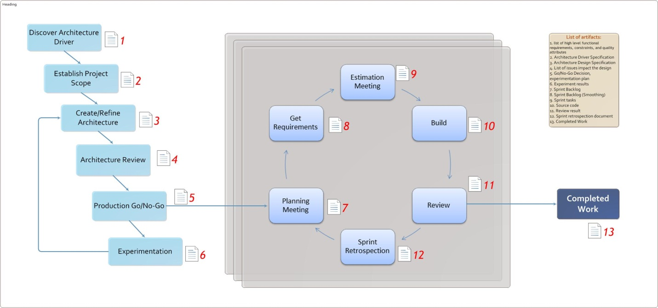

**Figure**: *ECM development lifecycle*

ECM Development Lifecycle is combines between ACDM model and Scrum process. ACDM consists of stage 1 to 6 and SCRUM consists of stage 7 to 12.

## IMPLEMENTATION

1. Discover architectural drivers

Interact with stakeholders to discover and document the raw architectural drivers.

*Artifact: List of high level functional requirements, constraints and quality attributes.*

1. Establish project scope

Refine raw architectural drivers into an architectural driver specification and define the scope the work.

*Artifact: Architecture Drivers Specification, Preliminary project plan*

1. Create/Refine architecture

Create or refine the architecture design. After initial design the architect (or architecture team) will return to this step after experimentation to refine the architecture.

*Artifact: Architecture Specification*

1. Architectural review

Review the architecture to discover and document issues that may compromise the satisfaction of the architectural drivers.

*Artifact: A list of issues uncovered during the evaluation that impact the design’s ability to satisfy the architectural drivers.*

1. Production go/no-go

Prioritize and list the issues discovered during the architecture review and decide whether the architecture is ready for production or needs to be refined. If a go decision is made, the team goes to stage 7; otherwise, the team will experiment to refine the architecture

*Artifact: Issue disposition document, Ago/no-go decision, Experimentation plan*

1. Experimentation

Team designs and plans experiment to mitigate risks or issues that were discovered during the review. One planned, the team carries out the experiments and documents the results. Based on the results of the experiments, the team refines the architecture (stage 3) design base.

*Artifact: Experimentation results.*

1. Planning meeting

Everyone will determine the work time for the sprint, divide work into smaller tasks, estimate the amount of time will do each task, complete the required which identify important task.

1. Get requirement

At the beginning of each sprint, the scrum team made clearly requirements in the Sprint backlog tasks to serve to estimate and perform the work in the sprint.

1. Estimation meeting

At the first team meeting of sprint, members will estimate your work based on the assigned workload. After team members to estimate their work, Managing Engineer will be aggregated and posted to Burn down chart.

1. Build

Producing Engineer will begin its work in the sprint. Each member will have to do all the work from detail design, programming and testing errors. Daily, each Producing Engineer‘s task has been made ​​will be updated to the Scrum board and burn down. Based on the estimated time and actual time the Managing Engineer to work for more rational adjustment.

1. Review

After completing the job in the previous step, the team will conduct a review of all. When the members have determined was completed, all the changes will be rejected and returned to the following sprint.

1. Sprint retrospection

Review, report and repeat. Meetings to assess the work done after each sprint of the members. Each person will present achieved what, feedback from customers, review sprint time. Looking back the burn down chart to determine the full and receive contributions in addition to continue to the next sprint.

1. Complete Work

After the completion of each sprint will be packaged and delivered to customers based on document defines the job done each sprint between the team and the customer built the start of each sprint. Release consists of source code, the detail design documents and test document.

# ROLES AND PERSONNEL IN PROJECT

See more in file attach: *[ECM]_Mapping roles_ver1.2.docx*